***Aura Women Chain New Style:***

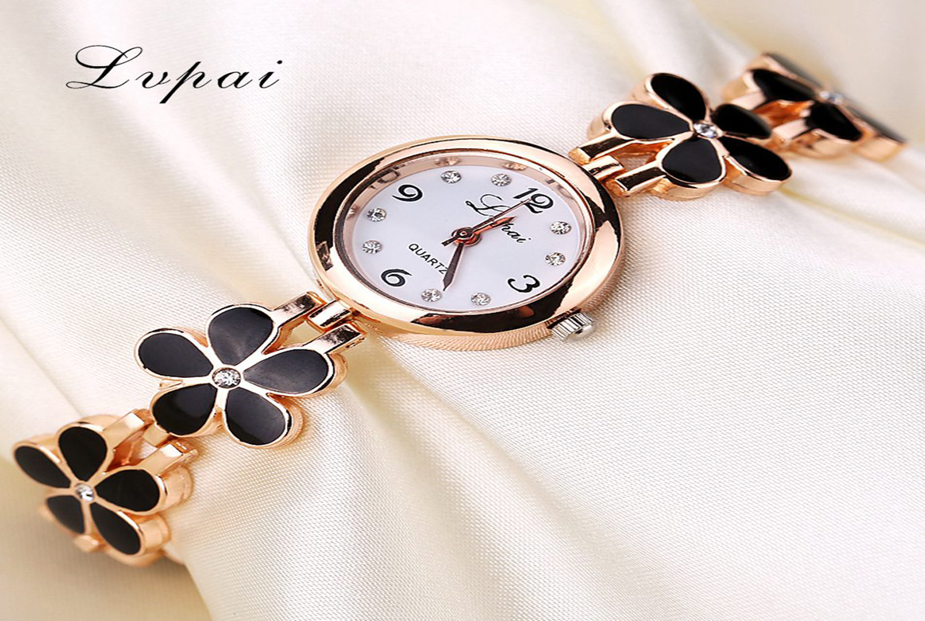

***Details About This Watch:***

MOVEMENT: MIYOTA 2035 (2 YEAR BATTERY LIFE)  
FUNCTIONS: HOURS, MINUTES, CENTRAL SECONDS  
CASE MATERIAL: HAND FINISHED 316L STAINLESS STEEL

***SPACES***

**DIAL COLOR:**Gold

**CASE SIZE:**34mm

**CASE SHAPE:**Round

***Price:***

***Rs:1,000***